**Assignment 24.5**

Create a hive table and load the dataset into the table and evaluate the below problem statements .

Here, first creating the table and then loading the data into the table.

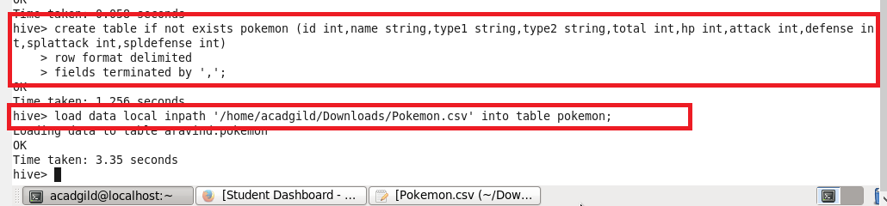

1. Find out the average HP (Hit points) of all the Pokemon.

Using avg function finding HP of all the pokemon.

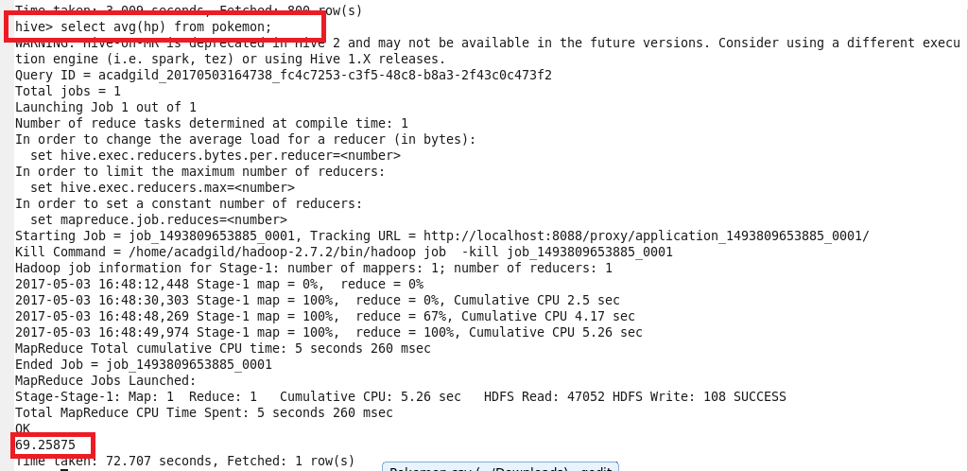

1. Find out the average Defense of all the pokemon.

Using avg function finding average Defense of all the pokemon.

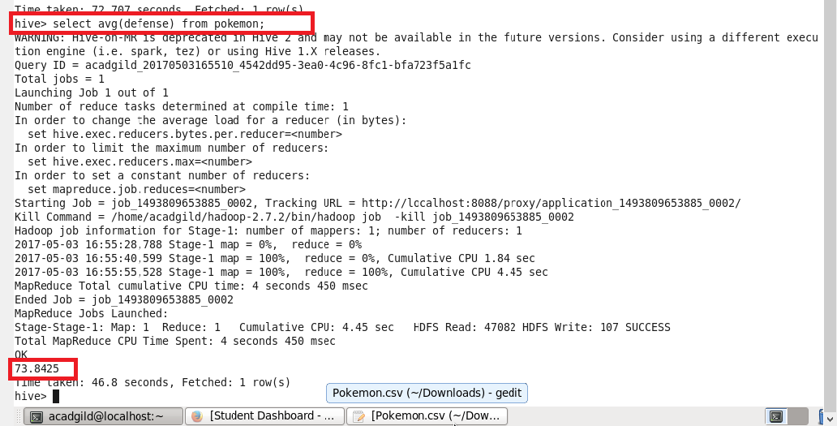

1. Find out the average Sp.Atk of all the pokemons.

Using avg function finding average Sp.Atk of all the pokemons

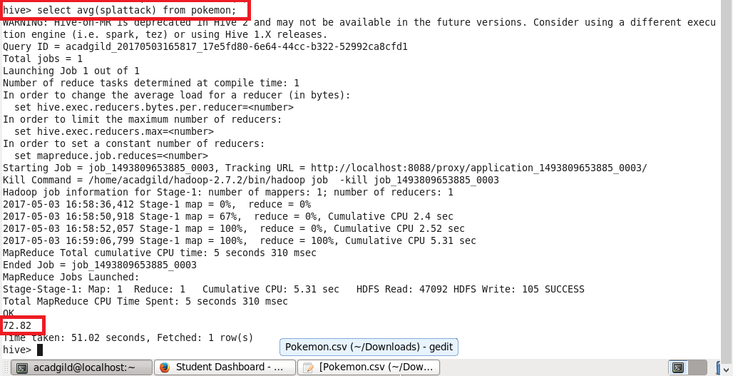

1. Find out the average sp.Def of all the pokemons.

Using avg function finding average sp.Def of all the pokemons .

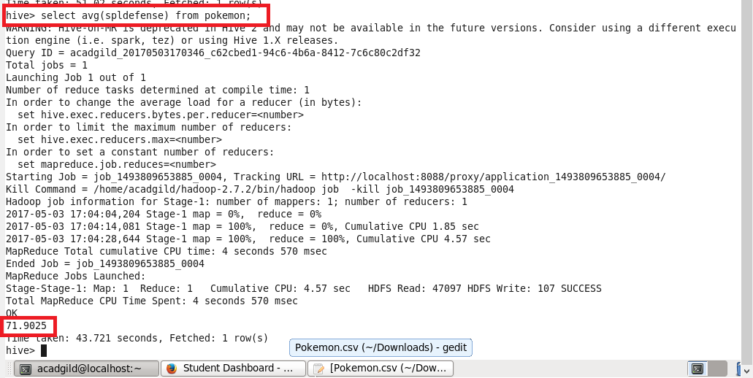

1. Find out the average Speed of all the pokemons.

Using avg function finding average Speed of all the pokemons.

